
KEMENTERIAN LINGKUNGAN HIDUP /
BADAN PENGENDALIAN LINGKUNGAN HIDUP
DEPUTI BIDANG PENGENDALIAN PENCEMARAN DAN KERUSAKAN LINGKUNGAN DIREKTORAT PERLINDUNGAN DAN PENGELOLAAN MUTU AIR

TERMS AND PROCEDURES FOR CONTINUOUS WASTE WATER MONITORING DATA SENDING (SPARING) IN 2025

- INTRODUCTION
- URL : sparing.kemenlh.go.id
- Monitoring Data Delivery is per hour, data with an interval of 2 minutes, so the total data sent is 30 (thirty) data, in one data delivery package
- The data sent at the Nth hour is the data at the N-1st hour, for example, at 09.00, it will send data at 08.00.00, 08.02.00, 08.04.00, 08.06.00, …, 08.58.00

- (REQUEST) API SECRET
- API SECRET applies generally (independent of the Company) and can change at any time, without notice.
- Functions as a SECRET KEY for the data encryption process
- Implementation :
    - API URL : https://sparing.kemenlh.go.id/api/secret-sensor
    - METHOD : GET

- ID LOGGER
- LOGGER ID is a unique code for each LOGGER owned by the company and has been registered by KLH/BPLH
- LOGGER ID is used as UID (Unique Identification) when sending data

- DATA SENDING FORMAT
- DATA VARIABLES:
  - uid: STRING data type in the form of a LOGGER ID;
  - datetime: INTEGER data type in the form of a time in UNIX TIMESTAMP format
  - pH: NUMBER data type in the form of a pH concentration value
  - cod: NUMBER data type in the form of a COD concentration value (mg/l);
  - tss: NUMBER data type in the form of a TSS concentration value (mg/l);
  - nh3n: NUMBER data type in the form of a NH3N concentration value (mg/l);
  - debit: NUMBER data type in the form of a DEBIT concentration value (m3/minute);
- DATA TYPE:
  - STRING is a data type consisting of numbers and/or alphabets.
  - INTEGER is a data type consisting of whole numbers;
  - NUMBER is a data type consisting of whole numbers or decimal numbers;
  - UNIX TIMESTAMP is an INTEGER data type that represents time;

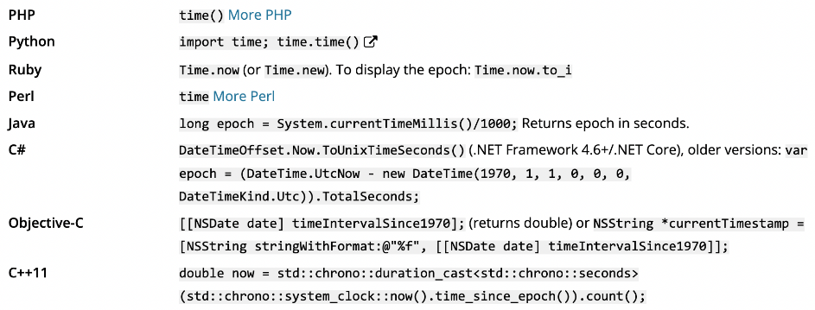

- DATA FORMAT:
  - Data format is in JSON (JavaScript Object Notation);
  - JSON is a popular data format used in system/application integration;

- DATA DELIVERY PER 2 MINUTES;
{
"uid": "ABC3fe3fa2366e1acce66XYZ",
"datetime": 1737972001,
"pH": 6.20,
"cod": 4.12,
"tss": 250,
"nh3n": 4.14,
"debit": 3.12
}

- HOURLY DATA DELIVERY (2 MINUTE INTERVAL);
{
"uid": "ABC3fe3fa2366e1acce66XYZ",
"data": [
{
"datetime": 1737968400,
"pH": 1,
"cod": 2,
"tss": 3,
"nh3n": 4,
"debit": 5
},

…… JUMLAH DATA 30 ……

{
"datetime": 1737971880,
"pH": 1,
"cod": 2,
"tss": 3,
"nh3n": 4,
"debit": 5
}
]
}

- DATA ENCRYPTION

- Encryption using JWT (JSON Web Tokens), a reference can be found at https://jwt.io/;
- JWT Header;
{
"typ": "JWT",
"alg": "HS256"
}

- Encrypt the HEADER and DATA using Base64UrlEncode and HMACSHA256;
- Combine the results of the HEADER encryption and DATA encryption with the dot (.) character;

dataEncode = Base64UrlEncode(HEADER) + "." + Base64UrlEncode(DATA);

- Create SECRET KEY from API KEY & DATA ENCODE using HMACSHA256;
- KEY SECRET encryption using Base64UrlEncode;

keySecret = Base64UrlEncode(HMACSHA256(dataEncode, API_KEY));

- Combine dataEncode and keySecret with a Dot (.) Character;

dataSend = dataEncode + "." + keySecret;

- SEND DATA in JWT format;
{
"token":
"eyJ0eXAiOiJKV1QiLCJhbGciOiJIUzI1NiJ9.eyJ1aWQiOiJBQkMzZmUzZmEyMzY2ZTF hY2NlNjZYWVoiLCJkYXRldGltZSI6MTczNzk3MjAwMSwicEgiOjYuMjAwMDAwMDAwMDAw MDAwMTc3NjM1NjgzOTQwMDI1MDQ2NDY3NzgxMDY2ODk0NTMxMjUsImNvZCI6NC4xMjAwM DAwMDAwMDAwMDAxMDY1ODE0MTAzNjQwMTUwMjc4ODA2Njg2NDAxMzY3MTg3NSwidHNzIj oyNTAsIm5oM24iOjQuMTM5OTk5OTk5OTk5OTk5NjgwMjU1NzY4OTA3OTU0OTE2MzU3OTk 0MDc5NTg5ODQzNzUsImRlYml0IjozLjEyMDAwMDAwMDAwMDAwMDEwNjU4MTQxMDM2NDAx NTAyNzg4MDY2ODY0MDEzNjcxODc1fQ.B2fGE6fpBGxqjgT7CimYOmQHO9t2sFEPqZgesC jjn-c"
}

- To ensure that the data sent is correct, it can be checked via https://jwt.io/;

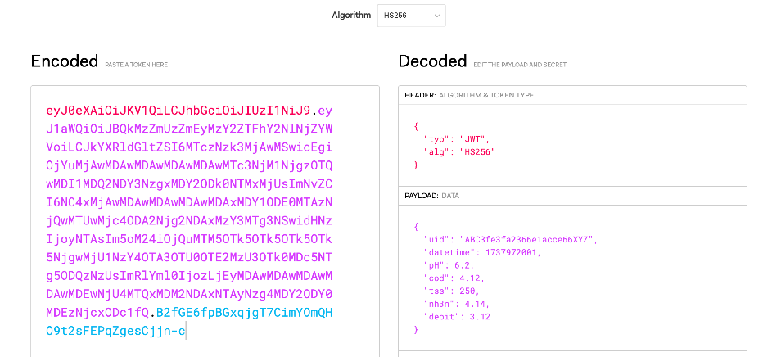

- Examples of encryption usage:
i. The JWT Programming Language Library can be found at https://jwt.io/libraries;
ii. PHP Programming Language;
function base64url_encode($data){
$b64 = base64_encode($data);
if ($b64 === false) return false;
$url = strtr($b64, '+/', '-_');
return rtrim($url, '=');
}
$password = "API_SECRET";
$header = ["typ" => "JWT", "alg" => "HS256"];
$jsonHeader = json_encode($header);

$data2Minute = [
"uid" => "ABC3fe3fa2366e1acce66XYZ",
"datetime" => strtotime("2025-01-10 08:00:00"),
"pH" => 6.2,
"cod" => 4.12,
"tss" => 250,
"nh3n" => 4.14,
"debit" => 3.12
];
$jsonData2Minute = json_encode($data2Minute);

$dataConversion = base64url_encode($jsonHeader) . '.' . base64url_encode($jsonData2Minute);
$keyConversion = base64url_encode(hash_hmac('sha256', $dataConversion, $password, true));
$dataKey = $dataConversion . '.' . $keyConversion;
$dataSend = ['token' => $dataKey];

$jsonDataSend = json_encode($dataSend);
echo $jsonDataSend;
iii. Python;

import jwt
jwtHeaders = {
"alg" : "HS256",
"typ" : "JWT"
}
jwtPayload = {
"name" : "Test",
"email" : "test@gmail.com",
"admin" : "true",
"exp" : 1689871805
}
key = "superSecretYouWillNeverGuess"
enc = jwt.encode(jwtPayload,key,algorithm='HS256',headers=jwtHeaders) print(enc)

- DATA SENDING
- TESTING DATA SENDING (TESTING / CONNECTIVITY TEST):
i. API URL : https://sparing.kemenlh.go.id/api/testing
ii. METHODE : POST
iii. HEADER : {content-type: application/json}
iv. BODY : SEND DATA (per 2 minutes)

- DATA SENDING EVERY 2 MINUTES:
i. API URL : https://sparing.kemenlh.go.id/api/send
ii. METHODE : POST
iii. HEADER : {content-type: application/json}
iv. BODY : SEND DATA (per 2 minutes)

- HOURLY DATA SENDING (2-MINUTE INTERVAL):
i. API URL : https://sparing.kemenlh.go.id/api/send-hourly
ii. METHODE : POST
iii. HEADER : {content-type: application/json}
iv. BODY : SEND DATA (Hourly)

- RETURN VALUES :
    - If VALID

{
"status": true,
"desc": null
}

    - If NOT VALID;
{
"status": false,
"desc": "……………"
}

